Twinside

Developer Tools



User Manual

# The package

The Twinside developer kit contains the following databases

* **Globals** : Flags, states, country codes, currency codes, languages, etc
* **Zip codes**: Generic zip code database – comes with DK, SE, and NO codes. Need other countries? Please send me an email with the zipcodes in a text file.
* **DbConfig**: Central registration of databases – for internal references
* **Graphic**: 10.000 Database icons, view icons and custom graphic
* **Agent log**: Script agents logs to this – for better monitoring/debugging
* **Media**: Container for web stylesheets, javascript files and graphics
* **Design template**: Sample database/framework with basic layout, navigation and keyword handling for both web and notes use
* **Code store**: Developers dream – documentation, reusable code, references, tips’n tricks – and the Developer Toolbar

# Disclaimer / license / feedback please

Well, we don’t offer any support and doesn’t give any guarantees! You can however, use the code in any way you like as long as you don’t resell the package.

If you find a bug, have an idea to new functionality or already have made your own improvements then please let’s us know. Just send an email to [jakob@majkilde.dk](mailto:jakob@majkilde.dk) and we will consider this for the next release.

Remember – you have free lifetime maintenance….

# Installation

Copy all files to a new folder in the Notes data directory – local or on the server (or replicated on several servers). Sign the databases and check the ACL settings.

Bookmark all databases and you are ready to go.

# Training

Do you need training? Please contact us. Our Certified Lotus Instructor will be happy to help with anything from a 1 hour introduction to a complete 10 days developer course.

# DbConfig

Register other databases in a central database. This is useful in inter database relations – e.g. @DbLookups

The central dbconfig.nsf database makes the setup and maintenance easy.

## Installation

The filename is fixed: dbconfig.nsf

The location is optional. Place the dbConfig in the root (of the Notes data directory) – this will be accessible for all applications. Or you can place it in a subdirectory – then it will only be used by other applications in the same directory or below.

Typically the production or master dbConfig is placed in the root – and the development/test dbConfig is placed in the developer folder.

## Setup

Create an entry in the dbConfig for each lookup database you have. The table below shows all the required fieldshttp://server/twinside4/dbConfig.nsf/ts.requiredField.gif?OpenImageResource on the form.

|  |  |
| --- | --- |
| Field name | Description |
| ID | Unique id. Use this id for later references to this database. |
| Category | For view sorting only. |
| Server | Server where the file is located. You can include multiple server names – the first match will be used. Just write the abbreviated server name or use:  * for the current server  [mail] for the users mail server  [home] for the users home server  [local] to use a local replica |
| Filename | The location of the database file. Start then filename with an slash (/) to use the full path or without to make a relative reference, e.g.:  /names.nsf = the address book in the notes data directory  names.nsf = use the file in the current directory |

### Exceptions

You can make exceptions or redirections.

Example: the twinside/twinside.nsf is replicated to all servers – except the mail server called MAILSRV/MAJKILDE.

First, create a database reference, defining the alias and default location. Then create an exception, defining what to do, if the user is located on the 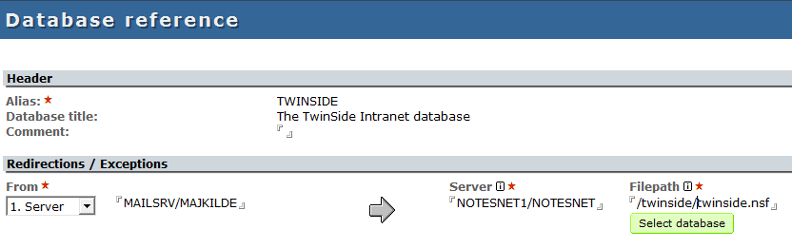‘empty’ mail server

## Using

You will find coding examples in the form called ‘Developer Demo’ in the dbconfig database.

From script you can get a database with this code:

Use “cls.fw”

Dim config As New DbConfig( )

Set db = config.getDatabase( "TWINSIDE" )

From @formula language you will include a copy of the ‘dbTwinside’ shared field on your form – renaming it to whatever to like. Just remember to change the alias in the first line:

alias := "TWINSIDE";

Your dblookup function will look like this:

@dbcolumn( “”; @replace( dbTwinside;”[local]”;””) ; “<view name>”, <column number>”

# Agent log

From your script agent, you can log any events or errors to the log database. Just include a few lines of code:

Use “cls.log”

Dim config As New DbConfig( )

Dim l As New DatabaseLog( config.getDatabase( "LOG" ))

Call l.write( LOG_NORMAL, "Your message", Nothing )

Call l.close()

First few lines are used to initialize the log. With the write() call you can write your own messages to the log. The function takes 3 parameters:

|  |  |
| --- | --- |
| Parameter | Description |
| Severity | Use LOG_DEBUG, LOG_VERBOSE, LOG_NORMAL, LOG_WARNING_LOW, LOG_WARNING_HIGH, LOG_FAILURE or LOG_FATAL |
| Message | String – the message to write |
| Link | NotesDatabase, NotesView or NotesDocument. Will create a Notes link in the doc document. Use Nothing to skip. |

Select ‘Administration, Setup’ in the log database to change the log settings:



# Code store / Developer toolbar

The code store has 5 sections:

* Documents
* Script libraries
* Code snippets
* Objects
* Developer Toolbar

## Documents

This is a library where you can store reference manuals, web links, coding guidelines etc. to share with other – or just for better findings and reuse.

The database comes with a lot of default references and tools.

## Script libraries – the DocTool

Script Library documentation. When you have created your own script library, click the ‘DocTool’ button to automatically generate a reference. Help and instructions found in %REM sections in your code is used to write the documentation.

## Code snippets

Reusable code, texts, tables, layouts are store here. Use the toolbar to select and copy – then just paste to reuse in your own design.

## Objects

Small code fragments are stored in the code snippet section. Selections of script libraries, forms, view etc can be created as an Object. From the toolbar it is all just a click away.

## Developer toolbar

In this section you will find an install button. Use this to get the Developer Toolbar:

 Code Store database with tips 'n tricks, references and documentation

 Code Snippets

 Copy Object

Create a design object from various forms, images, script libraries etc - and copy it all to any database with a single click

 Database Tool

Analyse design, remove design flags, basic database info

 Document info

 Data tool

 Update selected documents

 Remote server console

## Database tool

Shows detailed database information and gives you some advanced tools:

* Search the design for a field name or some code. In the result pane you can see all the design elements where the code is used.
* Delete the ‘Prohibit design’ flag and the ‘Inherit design from’ flag from all design elements
* Sign the database
* Hide script libraries or form script (keeping your code secure)
* Make a copy of the database with selected documents
* Manage profile document with view, edit or delete options

## Document info

Like the Notes document properties – but give you all the on the screen, ready to copy and paste or search in

## Data tool

With this tool you can manipulate your data:

* Sort a list
* Conversion tool between string and list
* Convert between decimal and hexadecimal
* @formula evaluator
* Search and replace

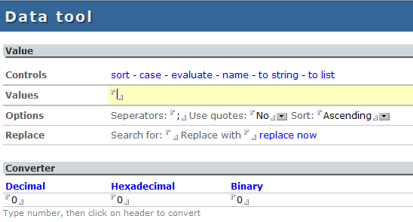

## Update selected documents

Change field values on selected documents – without creating an agent

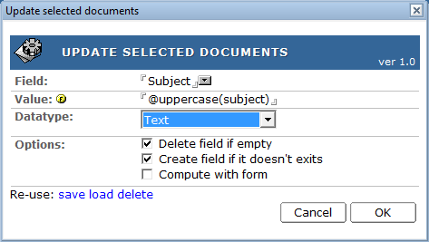

## Remote server console

Open a console window, so you can manage the server

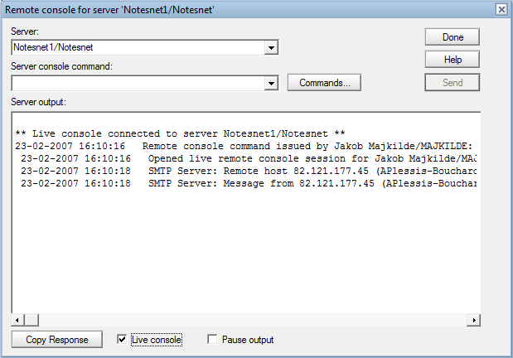

# Pricing

1 developer: dkr 5.000,-

5 developer: dkr 15.000,-

10 developer: dkr 25.000,-

Unlimited: dkr 30.000,-

All prices ex. vat and shipping. Free lifetime maintenance included. No support or guarantees. Resellers welcome. All applications are delivered with open documented source code.

